NGSS Transition Tool – adapting existing lessons/units/labs
Data team:  Teachers:  Date:  Sequencing in unit/curriculum  What is still needed? What “holes” are there?  Performance Expectation(s) | Learning goals / targets  Description of lesson | NGSS Disciplinary Core Idea(s):  NGSS Science & Engineering Practice(s):  NGSS Cross Cutting Concept(s):  © 2014 SCWIBLES scwibles.ucsc.edu GK­12 UCSC Graduate Training Program NSF DGE-­0947923 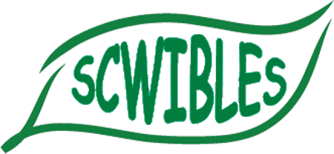
Expanded Development of Lesson Plan Transition
Prep time required | Class time required

Equipment | Consumables | Worksheets/Handouts/Links/Videos

Skills | Vocabulary | Equations

Evaluation: formative | Evaluation: summative

Pre-req Skills or Prior Knowledge | Sequencing in unit / curriculum

Opportunities for Inquiry | Smart Goals

To do: What | To do: Who | To do: By when

