

K-8 California’s
Common Core Standards
Parent
Handbook



California County Superintendents
Educational Services Association
© 2011 California County Superintendents Educational Services Association

Financial Support Provided By
The William and Flora Hewlett Foundation

Prepared By:

Contributions by Patricia Duckhorn, Tamara Wilson, Fran Gibson, Kathy Curl, Sue Stickel, California State PTA and Ventura County Office of Education
Contents

Introduction 4

Mathematics
Mathematics – Standards for Mathematical Practice 6
Grade K Overview 8
Grade 1 Overview 10
Grade 2 Overview 12
Grade 3 Overview 14
Grade 4 Overview 16
Grade 5 Overview 18
Grade 6 Overview 20
Grade 7 Overview 22
Grade 8 Algebra 1 Overview 25
Grade 8 Overview 28

English Language Arts
Grade K Overview 30
Grade 1 Overview 32
Grade 2 Overview 33
Grade 3 Overview 34
Grade 4 Overview 35
Grade 5 Overview 36
Grade 6 Overview 37
Grade 7 Overview 38
Grade 8 Overview 39
Introduction
This handbook gives parents an introduction to California’s Common Core Standards and a summary of what students are expected to learn as they advance from kindergarten through grade 8. The standards are designed to reflect the knowledge and skills that our young people need for success in college and careers. A common set of learning goals helps teachers and parents ensure students are challenged and making appropriate progress.

Why Common Core Standards?
California educators have joined a national movement to adopt common standards and assessments for English language arts and mathematics. Currently, standards for what students should know and be able to do vary among states, as does the difficulty of the assessments used to determine whether students are meeting those standards. Common standards allow for collaboration among states on best practices and professional development.
Common learning goals provide a clear vision of what educators and parents in all states should aim for. These learning goals help ensure that students meet college and work expectations, are prepared to succeed in a global economy and society, and are provided with rigorous content and application of higher knowledge thinking. Benchmarked against international standards, the Common Core Standards assist students in their preparation to complete the requirements for enrollment at a California public university.

California’s Adoption of Common Core Standards
Adopted in California in August 2010, the K-12 Common Core State Standards were developed through a state-led effort to establish consistent and clear education standards for English language arts and mathematics. The initiative was launched by and supported by the Council of Chief State School Officers and the National Governors Association. In the Common Core Standard adoption process, California added supporting standards to complete the unique picture necessary for California students.
The Common Core also added strength to the existing California standards by including additional standards for vocabulary and new standards for collaborative discussions. Literacy standards that focus on reading and writing instruction during history/social studies, science, and technology also were included. In mathematics, standards were added to demonstrate a stronger emphasis on number sense and algebraic thinking. Implementation of the Common Core in California’s schools will occur in stages over the next few years.
Organization of Standards
This handbook organizes information about the standards for English language arts and mathematics for each grade level or subject course from kindergarten through 8th grade. Each grade level provides a content overview and a summary of skills developed at that level. Additional information about grades 9-12 will be provided at a later date.
In English language arts, California Common Core Standards are organized into the following four groups: (1) reading, (2) writing, (3) speaking and listening, and (4) language.
Besides outlining mathematics content standards by grade level or course, this handbook also includes a set of behaviors and practices every student should develop which is called The Standards for Mathematical Practice. These practices deepen understanding of mathematics and enhance students’ problem solving abilities. Information about these practices is found on the next page.
Mathematics | Standards for Mathematical Practice

The Standards for Mathematical Practice describe behaviors that all students will develop in the Common Core Standards. These practices rest on important “processes and proficiencies” including problem solving, reasoning and proof, communication, representation, and making connections. These practices will allow students to understand and apply mathematics with confidence.

- Make sense of problems and persevere in solving them.
  - Find meaning in problems
  - Analyze, predict and plan solution pathways
  - Verify answers
  - Ask themselves the question: “Does this make sense?”

- Reason abstractly and quantitatively.
  - Make sense of quantities and their relationships in problems
  - Create coherent representations of problems

- Construct viable arguments and critique the reasoning of others.
  - Understand and use information to construct arguments
  - Make and explore the truth of conjectures
  - Justify conclusions and respond to arguments of others

- Model with mathematics.
  - Apply mathematics to problems in everyday life
  - Identify quantities in a practical situation
  - Interpret results in the context of the situation and reflect on whether the results make sense

- Use appropriate tools strategically.
  - Consider the available tools when solving problems
  - Are familiar with tools appropriate for their grade or course ( pencil and paper, concrete models, ruler, protractor, calculator, spreadsheet, computer programs, digital content located on a website, and other technological tools)

- Be precise.
  - Communicate precisely to others
  - Use clear definitions, state the meaning of symbols and are careful about specifying units of measure and labeling axes
  - Calculate accurately and efficiently

- Look for and make use of structure.
  - Discern patterns and structures
  - Can step back for an overview and shift perspective
  - See complicated things as single objects or as being composed of several objects

- Look for and identify ways to create shortcuts when doing problems.
  - When calculations are repeated, look for general methods, patterns and shortcuts
  - Be able to evaluate whether an answer makes sense

Grade K Overview | Mathematics

Kindergarten students learn to count to 100 and write numbers to 20. Attention is given to numbers 11-20 where emphasis is placed on tens and ones building a foundation for place value understanding. Beginning addition and subtraction starts in kindergarten. Students sort and classify groups of objects and identify basic shapes.

- Know number names and be able to count to 100
- Write numbers 0 – 20
- Learn about numbers 11-20, with tens and ones
- Count objects to tell the number of things in a group up to 20
- Compare numbers and groups
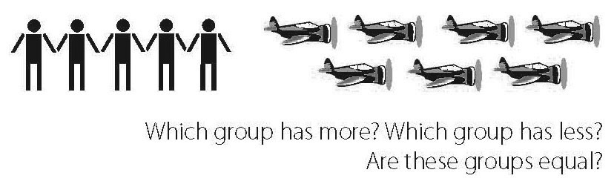

- Understand that addition is putting together groups and adding to groups
- Understand that subtraction is taking apart groups and taking from groups
- Fluently add and subtract within 5
- Understand concepts of time (morning, afternoon, evening, etc.)
- Know about the tools that measure time (clock, calendar, etc.)
- Sort objects into groups
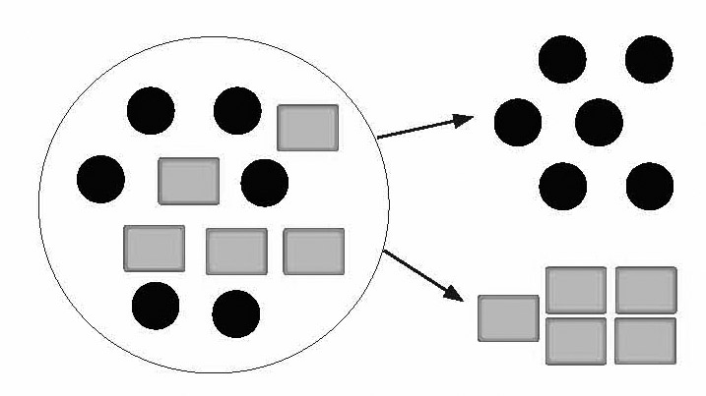

- Identify and describe shapes
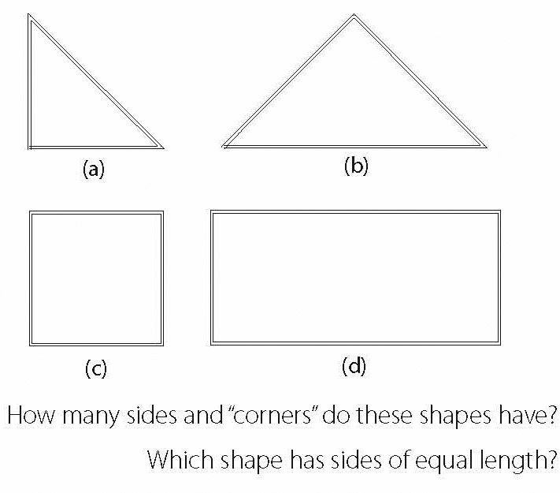
Grade 1 Overview | Mathematics

First grade students extend their understanding of addition and subtraction by learning to use adding and subtracting to solve word problems within 20. They understand the meaning of the equal sign and are expected to count to 120. Place value knowledge is deepened and students use this knowledge to compare two-digit numbers within 100. Students practice their measurement skills with linear measurement and begin to organize data from surveys. Students also tell and write time in hours and half-hours using analog and digital clocks.

- Solve addition and subtraction word problems within 20
- Understand the relationship between addition and subtraction
- Apply the properties of operations
  - Commutative property of addition:
If you know 8 + 3 = 11, then you know 3 + 8 = 11.
- Associative property of addition:
To add 2 + 6 + 4, the second two numbers can be
added to make a ten, so 2 + 6 + 4 = 2 + 10 = 12.

- Add and subtract within 20
- Count to 120, starting at any number
- Understand the meaning of the equal sign
- Understand place value: ones, tens
- Use place value to add and subtract within 100
- Measure lengths and tell the measurement in units
- Tell and write time
- Relate time to events (before/after, shorter/longer, etc.)
- Build and talk about a graph
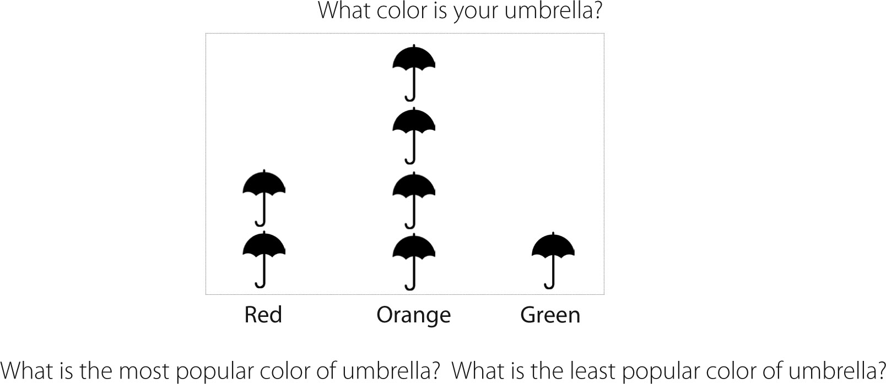

- Build, describe, extend, and explain a simple pattern.
- Compare shapes by talking about sides, vertices, etc.
- Compare two-dimensional shapes to three-dimensional shapes
Grade 2 Overview | Mathematics
Second grade students use addition and subtraction within 100 to solve word problems and are expected to know from memory all sums of two one-digit numbers by the end of second grade. Place value understanding is extended to 1000 and students compare three digit numbers based on their knowledge of hundreds, tens and ones. Second grade students compute with money and learn to estimate and compare lengths using appropriate measurement tools. Second graders refine their understanding of geometry by drawing shapes based on the number of faces and angles.

- Solve addition and subtraction word problems within 100
- Fluently add and subtract within 20
- Know all sums of two one-digit numbers
- Work with equal groups and repeated addition to understand multiplication


- Work with equal groups and repeated subtraction to understand division
- Understand place value: ones, tens, and hundreds
- Use place value to add and subtract within 1000
- Make reasonable estimates using place value knowledge
- Measure, estimate, and compare lengths in standard units
- Represent whole number lengths on a number line
- Work with time and money
- Know relationships of time (minutes in an hour, days in a month, etc.)
- Solve word problems using combinations of dollar bills and coins

- Collect data, build a graph, and answer questions about the data presented
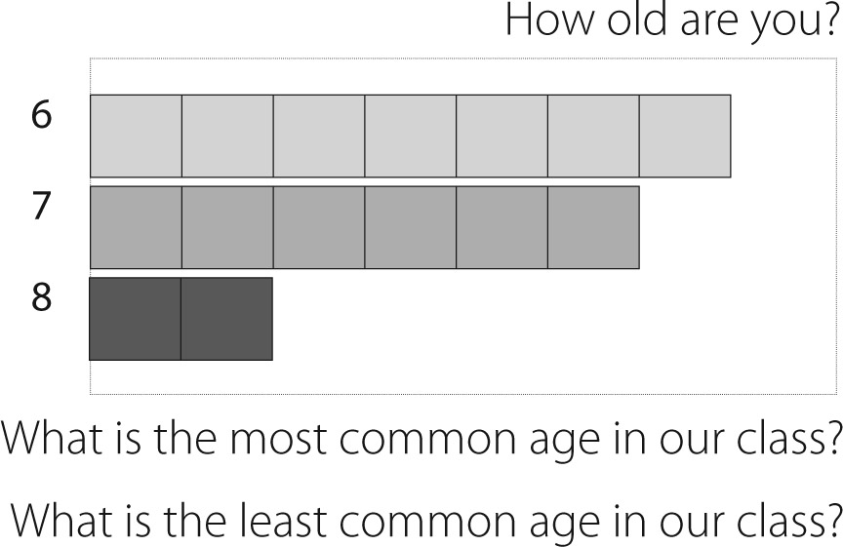

- Recognize shapes, triangles, quadrilaterals, pentagons, hexagons, and cubes
- Draw shapes by size of the angles or by the number of equal faces
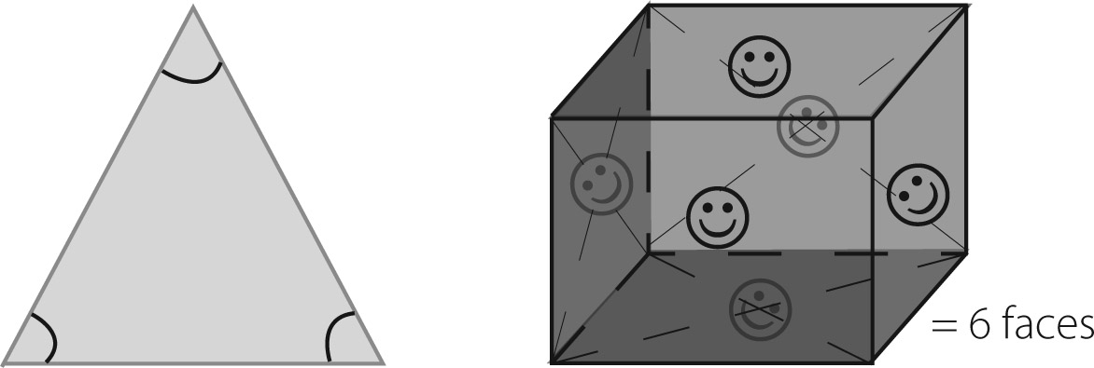
Grade 3 Overview | Mathematics
Third grade students develop an understanding of multiplication and division and learn to fluently multiply and divide within 100. Students are expected to know from memory all products of two one-digit numbers by the end of third grade. Place value understanding is used for multi-digit computation and estimation. Fractions are introduced in the third grade with an emphasis on understanding fractions as numbers and their relative size and placement on the number line. In third grade students understand concepts of area and perimeter and solve problems using liquid volume and mass.

- Solve multiplication and division word problems
- Understand the properties of multiplication
  - Commutative property of multiplication:
If you know 6 x 4 = 24, then you know 4 x 6 = 24.

- Associative property of multiplication:
3 x 5 x 2 can be found by 3 x 5 = 15, then 15 x 2 = 30,
or by 5 x 2 = 10, then 3 x 10 = 30.

- Distributive property of multiplication:
If 8 x 5 = 40
and 8 x 2 = 16,
then 8 x 7 is:
8 x (5 + 2)
(8 x 5) + (8 x 2)
40 + 16 = 56.

- Fluently multiply and divide within 100
- Know all products of two one-digit numbers
- Solve word problems with addition, subtraction, multiplication, and division
- Understand that multiplication and division are related
- Use place value to round numbers and know the value of each digit in a four-digit number
- Use place value understanding to solve multi-digit arithmetic
- Estimate reasonable answers using place value knowledge
- Understand fractions as numbers
- Recognize simple equivalent fractions
- Compare two fractions with the same numerator or the same denominator
- Know that 25 cents is ¼ of a dollar, 50 cents is ½ of a dollar and 75 cents is ¾ of a dollar
- Tell and write time to the nearest minute
- Estimate and measure time, volume, and weight
- Understand area and perimeter
- Understand that shapes in different categories can also be in a larger category
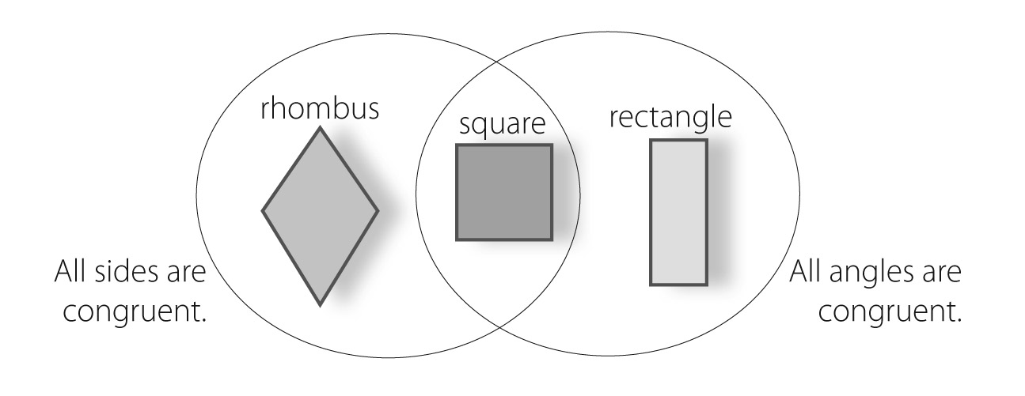

Grade 4 Overview | Mathematics
Fourth graders use their knowledge of place value to generalize to 1,000,000 and learn to round multi-digit whole numbers to any place. They fluently add and subtract using the standard algorithm and multiply and divide with multi-digit numbers. Fourth graders extend understanding of fractions to include equivalence, ordering and simple decimal notation. Students measure angles and classify geometric shapes by lines (parallel, perpendicular, etc.) and angles (right, acute, obtuse, etc.).

- Use addition, subtraction, multiplication, and division with whole numbers to solve word problems
- Learn about factors and multiples
  - Factors of 24: 1, 2, 3, 4, 6, 8, 12
  - Multiples of 4: 4, 8, 12, 16, 20
- Make and describe patterns with objects and numbers
- Understand and use place value to generalize to 1,000,000
  - Expanded form: 6783 = 6000 + 700 + 80 + 3
- Compute with multi-digit numbers
- Solve problems involving using multiplication of multi-digit by two-digit numbers
- Divide multi-digit numbers by one-digit divisor
- Round multi-digit numbers to any place
- Build understanding of equivalent fractions and ordering fractions
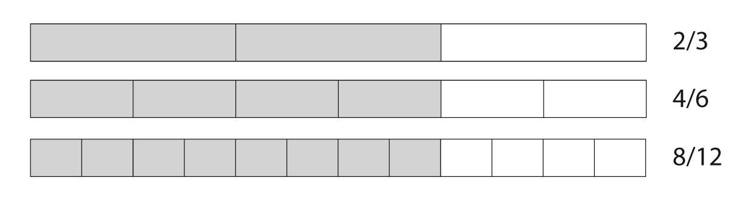

- Compare two fractions with different numerators and different denominators by making common denominators
- Add and subtract fractions and mixed numbers with like denominators
- Understand the decimal notation for fractions
- Compare decimals
- Solve problems using measurement conversions
- Apply area and perimeter formulas for rectangles
- Organize and explain data using a line plot
- Understand and measure angles
- Draw and identify lines and angles
- Describe and sort shapes by their lines and angles
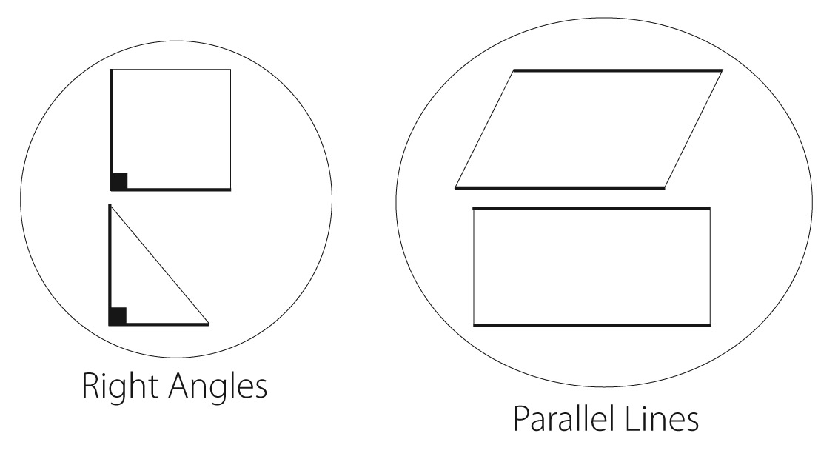

- Recognize lines of symmetry
Grade 5 Overview | Mathematics
Fifth grade students finalize fluency with multi-digit addition, subtraction, multiplication, and division. They apply their understanding of fractions to the addition and subtraction of fractions with unlike denominators, the concept of fraction multiplication and division, and decimal addition and subtraction. They analyze numeric patterns and relationships and graph ordered pairs on a coordinate plane. Students build on their understanding of geometry by recognizing attributes of geometrical shapes and calculating inside angle measurement and area of triangles and parallelograms.

- Write and interpret numerical expressions using parentheses, brackets, or braces
  - “Add 8 and 7, then multiply by 2” is 2(8 + 7)
- Express a whole number (2 – 50) as a product of its prime factors
- Describe more complex patterns by seeing the change
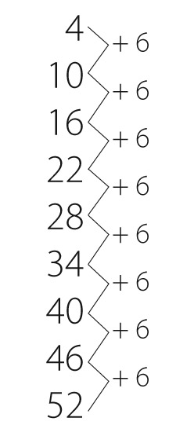

- Understand the place value system from thousandths to millions
- Fluently multiply multi-digit numbers using the standard algorithm
- Divide multi-digit numbers by two-digit divisors
- Read, write, and compare decimals to the thousandths
- Round decimals to any place
- Compute with multi-digit whole numbers and numbers with decimals to the hundredths
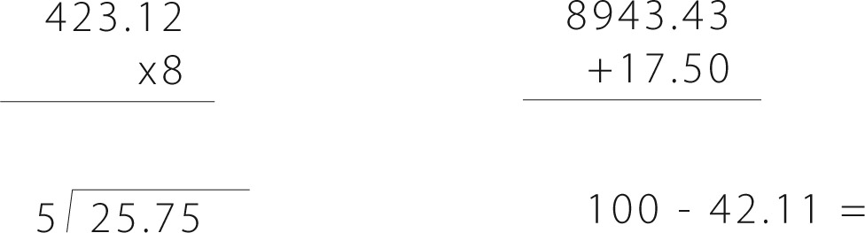

- Add and subtract fractions with unlike denominators
- Multiply fractions and mixed numbers
- Divide unit fractions by whole numbers and whole numbers by unit fractions
- Convert measurements and use in problem solving
  - 0.05 m = 5 cm or 2.5 feet = 30 inches

- Organize and explain data using a line plot
- Understand and find the volume of rectangular prisms
- Analyze number patterns
- Graph points on a coordinate graph
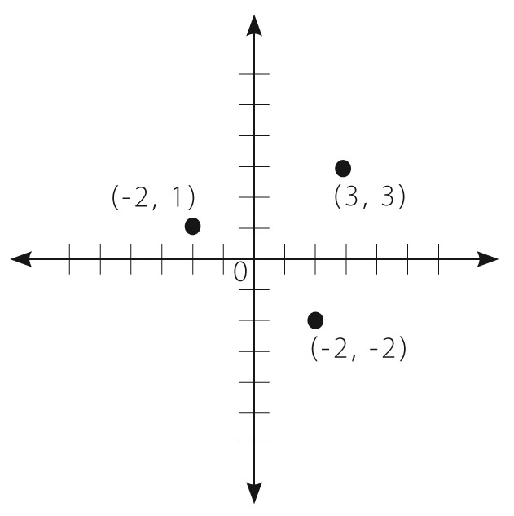

- Show a graph with an x and y axis with several points labeled by their coordinates
- Sort two-dimensional shapes into categories based on their properties
- Know what makes rectangles, parallelograms, and trapezoids different
- Know the inside sum of the angles of a triangle (180 degrees) and a quadrilateral (360 degrees)
- Be able to find the area of a triangle and parallelogram by knowing and understanding the formula for area of these shapes

Grade 6 Overview | Mathematics
Sixth grade students use their knowledge of multiplication and division to solve ratio and rate problems. They finalize their understanding of division of fractions and begin the study of negative integers. They understand the use of variables in mathematical expressions, write expressions and equations that correspond to situations, and use expressions and equations to solve problems. Students begin the study of probability and statistics and use their geometrical foundations to solve problems involving area, surface area, and volume.

- Understand ratio concepts and use ratio reasoning to solve problems
- Understand unit rate
- Find a percent of a quantity
- Divide fractions by fractions
- Fluently compute with multi-digit numbers and multi-digit decimals
- Find common factors and multiples of numbers
- Find the greatest common factor and least common multiple of two whole numbers
- Use understanding of positive numbers to understand rational numbers
- Understand positive and negative integers and be able to locate on a four-quadrant coordinate plane
- Order rational numbers
- Understand absolute value
- Add and subtract integers
- Apply properties of operations to add and subtract rational numbers
- Use understanding of arithmetic to solve one variable equations and inequalities
- Write expressions and equations to describe real world situations using variables
- Write and solve equations with whole number exponents
- Write an inequality to describe a real world or mathematical problem

- Represent and explain relationships between dependent and independent variables
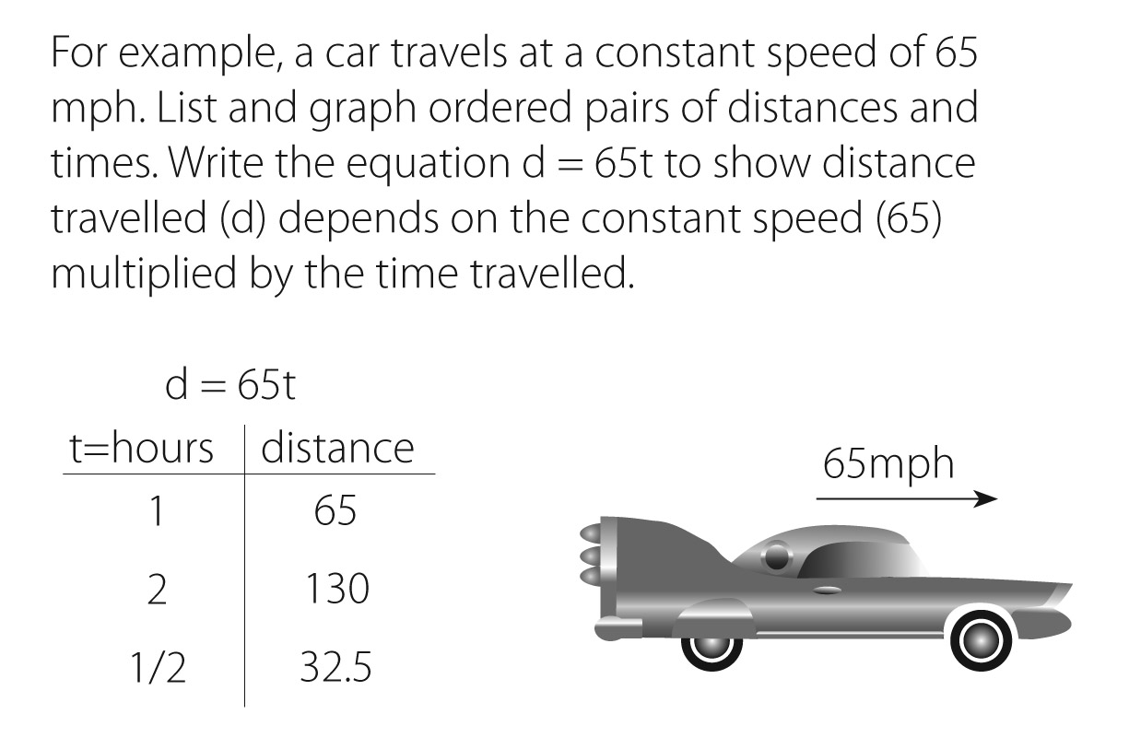

- Solve real world problems involving area, surface area, and volume
- Draw (freehand, with ruler and protractor and with technology) geometric shapes when given specific conditions
- Know the formulas for area and circumference of a circle
- Ask a statistical question (How old are the students in my school?), collect and organize the data on a line plot, graph, histogram, dot plot, box plot, etc.
- Describe and summarize data by noticing the center, spread, and overall shape
- Display numerical data on a number line including dot plots, histograms, and box plots
Grade 7 Overview | Mathematics
Seventh grade students deepen their understanding of proportional relationships to solve complicated problems. They extend their understanding of rational numbers to include computation (add, subtract, multiply, and divide). Irrational numbers are introduced in seventh grade. Algebraic foundations are practiced and extended. Students continue to extend their understanding of probability and statistics by describing populations based on sampling, and investigate chance to develop, use, and evaluate probability models.

- Use proportional relationships to solve multi-step operation and percent problems
  - If a person walks ½ mile in each ¼ hour, what is her speed per hour?

- Compute unit rates
- Add, subtract, multiply, and divide rational numbers
- Know irrational numbers (numbers that are not rational) and approximate them with rational numbers
  - The decimal of √2 (an irrational number) is 1.4142435623. Understand that √2 is between 1 and 2, then between 1.4 and 1.5, and explain how to continue on to get better approximations

- Use properties of operations to solve algebraic equations
- Use square root and cube root symbols to represent solutions to equations
- Evaluate square root and cube roots (of small perfect square roots and cube roots)
- Know that √2 is irrational
- Use numbers multiplied by a power of ten to estimate very large or very small quantities (the population of the United States is 3 x 10⁸)
- Add, subtract, factor, and expand linear expressions
- Construct simple equations and inequalities to solve problems
- Draw, construct, and describe geometrical figures and describe the relationships between them
- Solve problems involving angle measure, area, surface area, and volume (cylinders, cones, and spheres)
- Know formulas for volumes of cones, cylinders, and spheres
- Know the formulas for area and circumference of a circle
- Use random sampling to describe and compare populations
- Find, calculate, and explain the probability of a chance event
  - For example, if a student is selected from a class, find the probability that Jane will be selected and the probability that a girl will be selected.
  - Or if 40% of donors have type A blood, what is the probability that it will take at least 4 donors to find one with type A blood?
Grade 8 Options | Mathematics

California acknowledges that the goal for 8th grade students is Algebra 1. However, not all 8th grade students have the necessary prerequisite skills for Algebra 1. Therefore, California adopted standards that have been arranged into 2 sets for 8th grade. The first set describes standards for Algebra 1 and the second set is the grade 8 standards published in the Common Core document. Each set of standards prepares students for the rigor of high school mathematics. Neither set is considered below appropriate grade level mathematics.
Grade 8 Algebra 1 Overview

Eighth grade Algebra 1 students begin their study of Algebra by analyzing and solving equations, including linear equations, inequalities, systems of equations and polynomials. Algebra and geometry knowledge combine to define, compare and solve more complicated functions. Students prove simple geometric theorems algebraically.

- Extend the properties of exponents to rational exponents
- Work with radicals and integer exponents
- Use similar triangles to explain that the slope is the same between any two points on a line
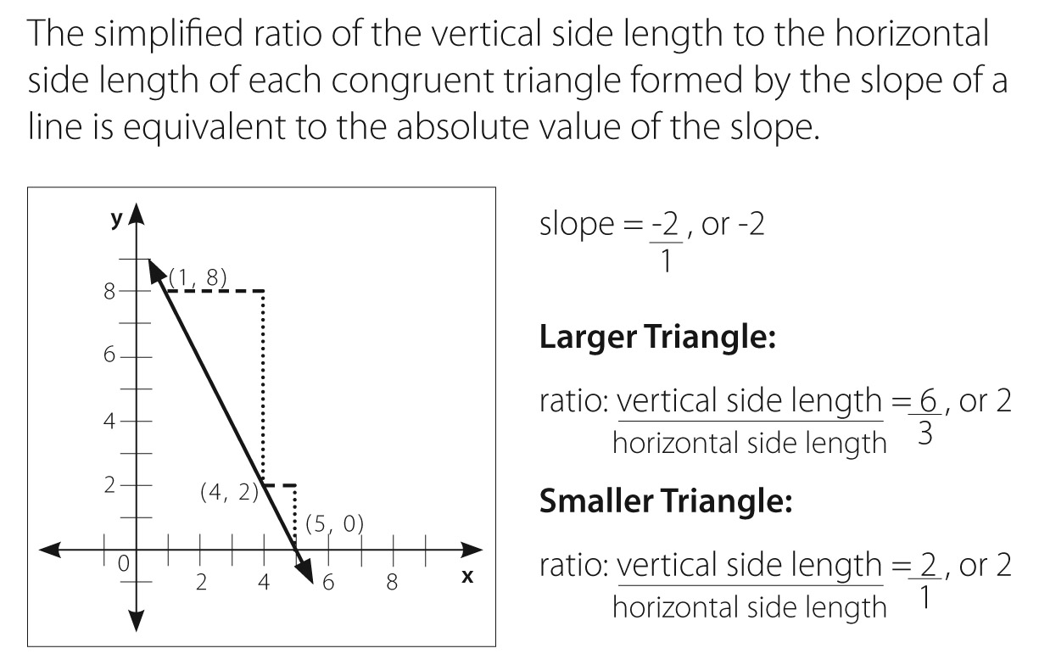

- Understand the connections between proportional relationships, lines, and linear equations
- Perform operations with numbers expressed in scientific notation

- Understand y = mx + b describes a line that intercepts the vertical axis
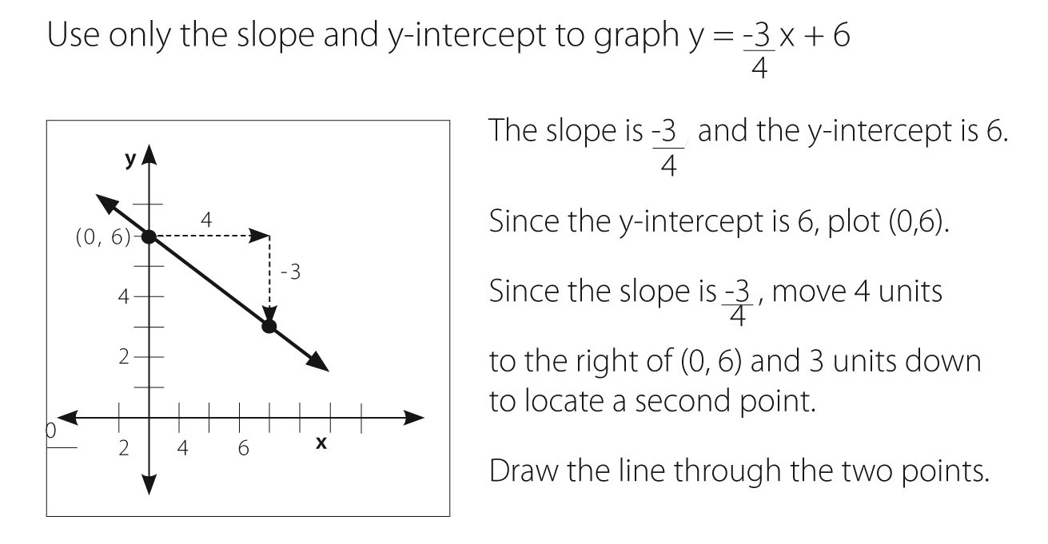

- Analyze and solve linear equations and pairs of simultaneous linear equations
- Interpret the structure of expressions (terms, factors, coefficients)
- Write expressions in equivalent forms to solve problems
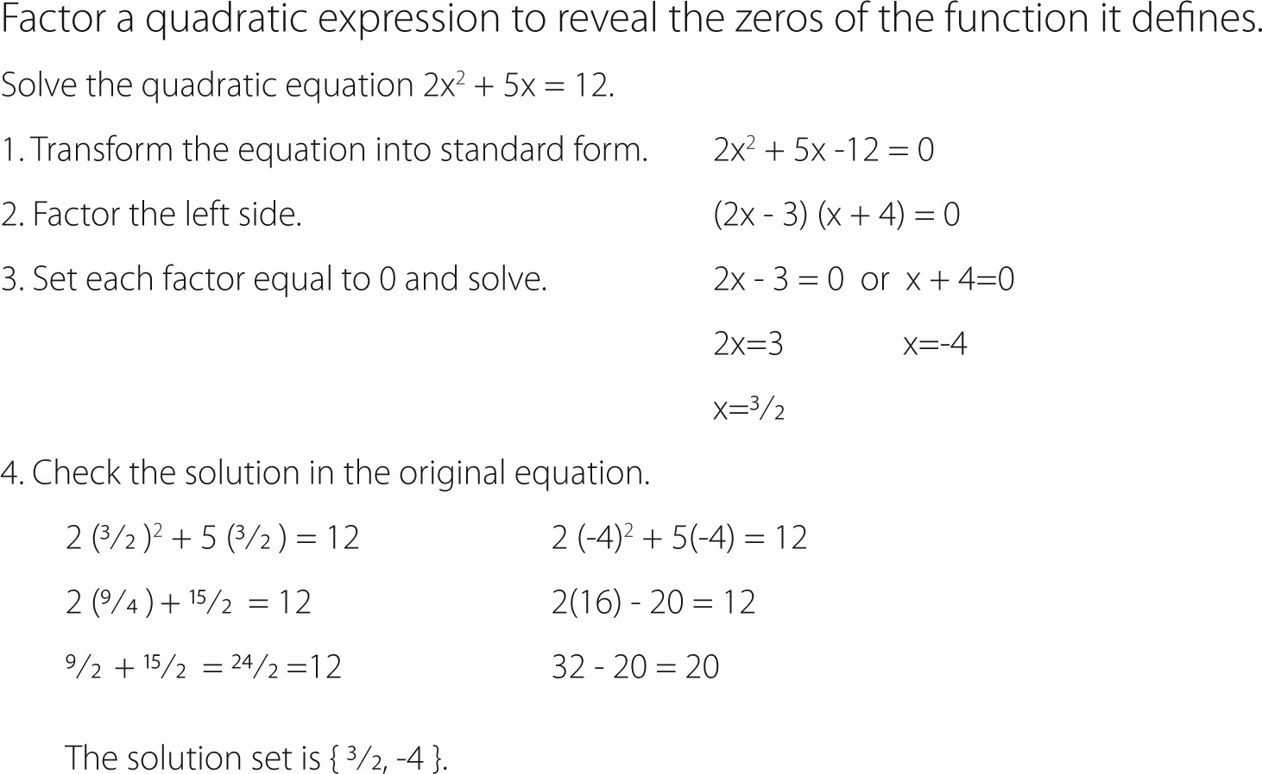

- Perform arithmetic operations on polynomials
- Create equations that describe numbers or relationships
- Create equations in two or more variables
- Solve equations and inequalities with one variable
- Solve systems of equations in two variables
- Graph and understand solutions to linear equalities and inequalities in two variables
- Solve quadratic equations with one variable
- Represent and solve equations and inequalities graphically
- Define, evaluate, and compare functions
- Use functions to model relationships between quantities
- Analyze and graph functions
- Build and write a function that models a relationship between two quantities
- Build new functions from existing functions
- Understand congruence and similarity
- Understand and apply the Pythagorean Theorem
- Use coordinates to prove simple geometric theorems algebraically
- Investigate patterns of association in sets of data
- Construct and interpret scatter plots
- Use and know simple aspects of a logical argument
- Use properties of the number system to judge the validity of results, to justify each step of a procedure, and to prove or disprove statements
Grade 8 Overview | Mathematics
Eighth grade students deepen their understanding of rational and irrational numbers. Algebraically, students compute with radicals and exponents, solve linear equations and define, solve, compare, and graph functions. In geometry, seventh grade students understand and use the Pythagorean Theorem and solve problems involving volumes of cylinders, cones, and spheres.

- Understand rational and irrational numbers
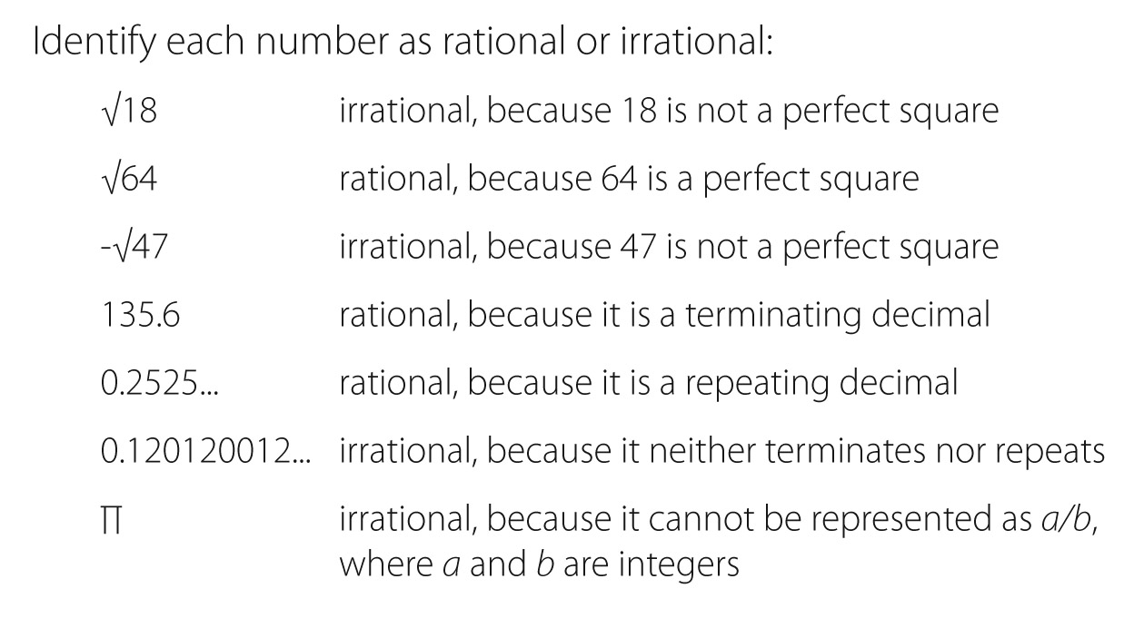

- Work with radicals and integer exponents
  - For example, estimate the population of the United States as 3 x 10⁸ and the population of the world as 7 x 10⁹, and determine that the world population is more than 20 times larger.
- Understand the connection between proportional relationships, lines, and linear equations and be able to graph them
- Understand that the unit rate of a proportional relationship is the slope of the graph
- Use similar triangles to explain slope and understand y = mx + b
- Analyze and solve linear equations with one variable and pairs of simultaneous linear equations
- Define, solve, and compare functions
- Understand that a function is a rule and the ordered pairs are input and output
- Build and use functions to model relationships
- Understand congruence and similarity
- Understand, use, and apply the Pythagorean Theorem
- Investigate patterns of sets of data
- Construct and interpret scatter plots
- Solve problems involving volumes of cylinders, cones, and spheres
- Construct and interpret scatter plots
Grade K Overview | English Language Arts
Kindergarten students work with prompting and support to interact with literature or informational text by asking and answering questions and identifying details and main events. Students know and can name all letters, and they can print many letters. They can read common words and draw, tell or write about a book.
Reading
With prompting and support:
- Ask and answer questions about a reading selection
- Identify characters, setting, and main events in a story
- Retell stories, including details

Reading: Foundational Skills
- Understand basic print features
    - Left to right
    - Top to bottom
    - Page by page

- Recognize and name all uppercase and lowercase letters
- Recognize that spoken words are made up of syllables and sounds
- Recognize and produce rhyming words
- Blend two or three sounds together to make a recognizable word
- Use phonics when reading words
- Say the most frequent sounds for each consonant and vowel
- Read common high-frequency words by sight
  - The, of, to, you, is

Writing
- Draw, tell, or write about a book
- Draw, tell, or write about events in the order they happened

Speaking and Listening
- Participate in discussions
  - Listen to others
  - Take turns speaking
- Follow oral directions
- Ask and answer questions
- Describe people, places, things, and events, providing detail

Language
- Print many uppercase and lowercase letters
- Use capitalization, punctuation, and spelling
- Identify new meanings for familiar words
  - Knowing duck is a bird, and learning the verb form of to duck

- Sort common objects into categories
  - Shapes, food

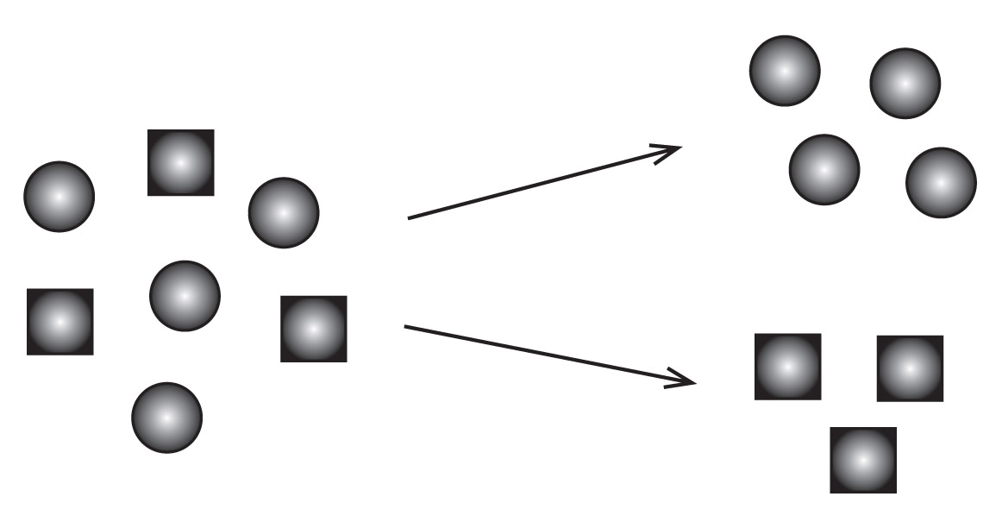

Grade 1 Overview | English Language Arts

First grade students independently interact with literature or informational text by asking and answering questions and identifying details and main events. They can read aloud accurately and with expression. First grade students can print all letters and can write about events, topics, and opinions.

Reading
- Ask and answer questions about details in a reading selection
- Retell stories, including details
- Explain the differences between books that tell stories and books that give information
- With prompting and support, read first grade informational texts

Reading: Foundational Skills
- Understand the organization and basic features of print
  - Left to right
  - Top to bottom
  - Page by page

- Recognize features of a sentence
  - Capitalization
  - Ending punctuation

- Understand spoken words, syllables, and sounds
- Understand phonics and word analysis
  - Know that every syllable must have a vowel sound
- Read regularly spelled one- and two-syllable words
- Read aloud with accuracy and expression

Writing
- Write opinion pieces that include an opinion and the reason for the opinion
- Write informative pieces that name a topic, supply facts, and provide closure
- Write narratives about two or more events in the correct order; include details

Speaking and Listening
- Follow rules for discussions by building on what others are saying and by asking questions
- Follow simple two-step directions
- Speak in complete sentences

Language
- Use correct grammar
- Print all uppercase and lowercase letters
- Use correct capitalization, punctuation, and spelling
- Determine meaning of unknown words by looking at parts of the word and other words in the sentence
- Sort words into categories and define words by key attributes
  - A tiger is a large cat with stripes
Grade 2 Overview | English Language Arts

Second grade students accurately read and understand literature and informational text. They use correct grammar, capitalization, punctuation, and spelling. They can plan and deliver a presentation about a story or experience.

Reading
- Retell folktales, including a central lesson
- Explain how the author uses reasons to support specific points in a text
- Identify the main topic and focus
- Read and understand literature and informational texts

Reading: Foundational Skills
- Know and use phonics and word analysis skills
  - Read words with common prefixes and suffixes (e.g., re_, un_, _less)

- Distinguish long and short vowels
- Read regularly spelled two-syllable words with long vowels
- Read accurately and with understanding

Writing
- Write opinion pieces that connect the opinion and reasons using linking words
  - Because, and, also

- Write informative pieces that provide a topic, facts, definitions, and a conclusion
- Write narrative pieces that include details to describe actions, thoughts, and feelings
- Produce writing that is developed, focused, and organized
- Write routinely over extended time frames and shorter time frames

Speaking and Listening
- Participate in conversations with peers and adults in small and larger groups
- Recall and describe key ideas and details from something read aloud
- Give and follow three- and four-step oral directions
- Plan and deliver a presentation about a story or experience

Language
- Use correct grammar
- Create readable documents with legible print
- Use correct capitalization, punctuation, and spelling
- Use a variety of methods to determine word meaning
- Use individual words to determine the meaning of compound words, which are two words joined to form a new word
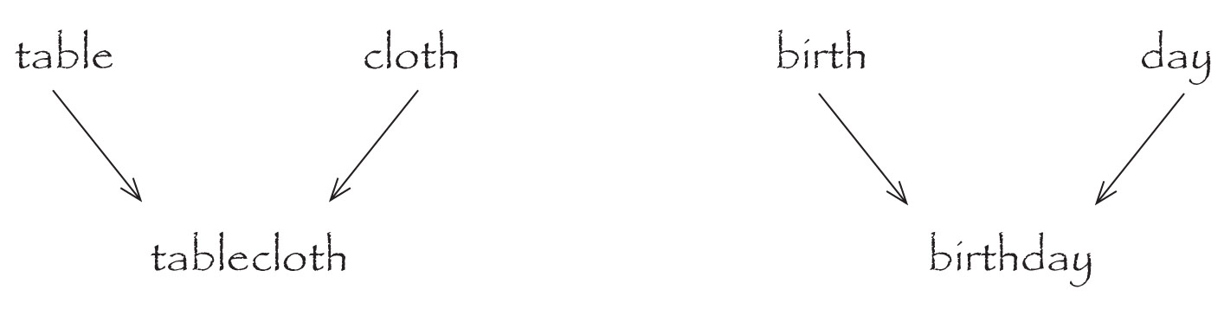

Grade 3 Overview | English Language Arts

Third grade students interact with literature and informational text by comparing and contrasting stories, discussing a point of view and comparing it with the author’s, and describing a series of events, ideas, or concepts. Along with their reading, third grade writing is more sophisticated. Students produce developed, focused, organized, and edited work. In writing informational pieces, they include charts or graphs and supply facts.

Reading
- Describe how characters’ actions contribute to the events
- Compare and contrast stories
- Independently read and understand grade-level literature
- Describe a series of events, ideas, or concepts
- Discuss a point of view and compare it to that of the author

Reading: Foundational Skills
- Use grade-level phonics and word analysis skills
  - Read words with multiple syllables, e.g., mosquito, puppeteer
- Know the meanings of most common prefixes and suffixes
- Read accurately and with understanding

Writing
- Write opinion pieces that include a chart or graph and list reasons that support the opinion
- Write informative pieces that name the topic, supply facts, and use linking words and phrases
- Write narrative pieces that introduce a narrator and characters, and write about what the characters say, think, and feel
- Produce writing that is developed, focused, organized, and edited

Speaking and Listening
- Follow rules for discussions by building on what others are saying
- Recall ideas and details from something read aloud
- Plan and deliver an informative presentation
- Speak clearly and in complete sentences

Language
- Use correct grammar
- Write legibly in cursive or joined italics; use margins and spacing
- Choose words and phrases for effect
- Use a variety of sentence types
- Capitalize appropriate words
- Correctly add suffixes to base words
  - Sitting, smiled, cries

- Recognize the differences between spoken and written standard English

Grade 4 Overview | English Language Arts

Fourth grade students read longer words and use roots, prefixes, and suffixes to determine the meanings of unknown words. They use details and examples in the text to determine the main idea and describe a character, setting, or event. Students produce writing that is developed, focused, organized, and edited. They group related ideas in paragraphs and sections, and provide a conclusion. Fourth grade students know when to use formal English, and when informal English is appropriate.

Reading
- Use details and examples in the text to determine the main idea and describe a character, setting, or event
- Use first person (e.g., I said) and third person (e.g., She said) narrative styles
- Read and understand literature and informational texts

Reading: Foundational Skills
- Use grade-level phonics and word analysis skills
  - Roots, prefixes, and suffixes
- Read words with multiple syllables
- Read with accuracy and understanding

Writing
- Write opinion pieces that include a conclusion related to the opinion
- Write informative pieces that group related ideas in paragraphs and sections, and provide a conclusion
- Write narratives that introduce a narrator and characters; write about what the characters say, feel, and think; use sensory details
  - Sight, sound, scent
- Produce writing that is developed, focused, organized, and edited
- Write a short research piece

Speaking and Listening
- Participate in discussions, carrying out assigned roles
- Paraphrase portions of information presented aloud
- Plan and deliver a presentation based on a personal experience
- Speak clearly, in complete sentences, and at an appropriate pace

Language
- Use correct grammar
- Use complete sentences
- Correctly use frequently confused words
  - To, two, too
  - There, their, they’re

- Use correct capitalization, punctuation, and spelling
- Spell grade-level words correctly
- Know when to use formal English and when informal English is appropriate

Grade 5 Overview | English Language Arts

Fifth grade students build on their ability to read longer words, using roots, prefixes, and suffixes to determine the meaning of unknown words. Students explain how an author supports points in a text. They use quotes accurately when referring to the text. Students keep the audience in mind and include a clear sequence of events when writing. Students listen to a speaker or media source and identify reasons and evidence provided to support particular points. They identify and discuss misleading ideas.

Reading
- Quote accurately when referring to text
- Determine the main ideas and summarize the text
- Compare and contrast texts
- Explain how an author uses reason or evidence to support points in a text

Reading: Foundational Skills
- Use grade-level phonics and word analysis skills
  - Roots, prefixes, and suffixes
- Read with accuracy and fluency

Writing
- Write opinion pieces that support a point of view with reasons and information
- Write informative texts that share ideas and information
- Write narratives that use related descriptive details and a clear sequences of events
- Write clearly and with a purpose; keep the audience in mind
- Use technology to publish writing; type two pages in a single sitting

Speaking and Listening
- Summarize information presented
- Identify reasons and evidence a speaker or media source provides to support particular points
- Identify and discuss misleading ideas
- Plan and deliver a speech
- Deliver a memorized poem or section of a speech
- Use expression and gestures

Language
- Use correct grammar
- Use verb tenses correctly
  - Yesterday I walked
  - Today I walk
  - Tomorrow I will walk

- Use correct capitalization, punctuation, and spelling
- Use punctuation to separate items in a series/list
- Use underlining, quotation marks, or italics in a title
- Vary sentence length and style
- Compare and contrast styles used in literature
- Use a variety of methods to determine the meaning of an unknown word
Grade 6 Overview | English Language Arts

Sixth grade students provide a summary of reading without personal opinions or judgments. They write a variety of pieces, including research projects, and use technology to publish the work. When presenting, students place descriptions, facts, and details in a logical order.

Reading
- Determine main idea and supporting details
- Provide a summary without personal opinions or judgments
- Determine how the structure of a text contributes to the main idea
- Determine an author’s point of view
- Explain how the point of view of the narrator or speaker is developed
- Distinguish among fact, opinion, reasoned judgment, and speculation in a text
- Read and understand grade-level literary and nonfiction texts

Writing
- Write arguments to support claims with clear reasons and relevant evidence
- Write informative texts that examine a topic and convey ideas
- Write narratives that include relevant descriptive details and well-structured event sequences
- Conduct short research projects and refocus the inquiry as needed
- Use technology to produce and publish writing; type three pages in a single sitting

Speaking and Listening
- Participate in discussions, both one-on-one and with a group
- Find claims supported by reasons and evidence in a speaker’s argument
- Plan and deliver an informative presentation
- Place descriptions, facts, and details in a logical order when presenting

Language
- Use correct grammar and language
- Use correct capitalization, punctuation, and spelling
- Use a variety of methods to determine the meaning of unknown words
- Distinguish among words with similar meanings
  - Stingy, economical, thrifty

Grade 7 Overview | English Language Arts

Seventh grade students read and understand grade-level nonfiction literature. They compare and contrast fictional and historical accounts. Students write a variety of pieces, creating organized arguments to support claims. When writing research projects, students collect additional questions for further research. They use eye contact, appropriate volume, and clear pronunciation when presenting.

Reading
- Explain what the text says and draw conclusions
- Determine the main ideas of a text and how they develop
- Analyze how the elements or setting of a story shape the plot
- Analyze how an author develops and contrasts his or her own point of view with those of characters or the narrator
- Analyze the structure of text
  - Graphics, headers, and captions

- Compare and contrast fictional and historical accounts
- Assess the extent to which the reasoning and evidence in a text support the author’s claims
- Read and understand grade-level literary and nonfiction texts

Writing
- Write arguments to support claims with clear reasons and relevant evidence
- Write informative texts that examine a topic and convey ideas
- Write narratives that include relevant descriptive details and well-structured event sequences
- Conduct research projects and demonstrate an understanding of the subject under investigation
- Use technology to produce and publish writing; include references and links to sources

Speaking and Listening
- Participate in discussions, both one-on-one and with a group
- Evaluate the reasoning and relevance of evidence made in a speaker’s argument
- Plan and present an argument
- Use eye contact, appropriate volume, and clear pronunciation when presenting

Language
- Use correct grammar and language
- Use correct capitalization, punctuation, and spelling
- Use a variety of methods to determine the meaning of unknown words
- Use relationships between words to better understand words
  - Synonym: a word that means the same
  - Antonym: a word that means the opposite

Grade 8 Overview | English Language Arts

Eighth grade students interact a great deal with literature and informational text. They use evidence from selections to analyze characters’ points of view and how the author uses dialogue. Students cite textual evidence to support their analysis of text and identify how the structure contributes to the meaning and style of each text. In writing, students show relationships among experiences and events.

Reading
- Use evidence when drawing conclusions from the reading
- Determine a theme and its relationship to the characters, setting, and plot
- Analyze how dialogue affects the outcome of a text
- Identify how the structure contributes to the meaning and style of each text
- Analyze how the points of view of the characters and the reader create effects such as suspense or humor
- Determine an author’s response to conflicting viewpoints
- Evaluate an author’s premises or hypotheses by corroborating or challenging conclusions with other sources of information
- Read and understand grade-level literary and nonfiction texts

Writing
- Write arguments to support claims with clear reasons and relevant evidence
- Write informative texts that examine a topic and convey ideas
- Write narratives that show the relationships among experiences and events
- Conduct research projects and demonstrate an understanding of the subject under investigation
- Use technology to produce and publish writing and present relationships between information and ideas

Speaking and Listening
- Participate in discussions, one-on-one and with a group
- Identify when irrelevant evidence is used in a speaker’s claim
- Plan and present a narrative
- Use eye contact, appropriate volume, and clear pronunciation when presenting

Language
- Use correct grammar and language
- Use correct capitalization, punctuation, and spelling
- Use a variety of methods to determine the meaning of unknown words
- Interpret figures of speech
  - Verbal irony
  - Puns

