Phone: (650) 543-4800
Email: records@fb.com
SnailMail: 1601 Willow Road, Menlo Park CA 94025
Fax: (650) 472-8007

Help Center:
https://www.facebook.com/help/?ref=contextual
How to Report Things:
https://www.facebook.com/help/181495968648557/
Report a Violation:
https://www.facebook.com/help/263149623790594/
Example:
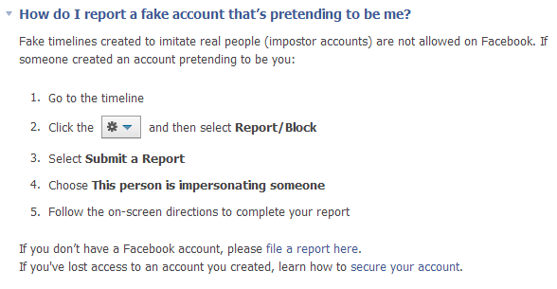
Facebook Community Standards:
https://www.facebook.com/communitystandards
Examples:
- Bullying and Harassment
Facebook does not tolerate bullying or harassment. We allow users to speak freely on matters and people of public interest, but take action on all reports of abusive behavior directed at private individuals. Repeatedly targeting other users with unwanted friend requests or messages is a form of harassment.
- Hate Speech
Facebook does not permit hate speech, but distinguishes between serious and humorous speech. While we encourage you to challenge ideas, institutions, events, and practices, we do not permit individuals or groups to attack others based on their race, ethnicity, national origin, religion, sex, gender, sexual orientation, disability or medical condition.
Give Feedback:
https://www.facebook.com/help/127103474099499/
Guidelines for Law Enforcement:
https://www.facebook.com/safety/groups/law/guidelines/

For more information about how to deal with bullying, please review the following resources:
- A Thin Line: MTV's A Thin Line campaign empowers kids to identify, respond to, and stop the spread of digital abuse in their own lives and among their peers. The campaign is built on the understanding that there's a "thin line" between what may begin as a harmless joke and something that could end up having a serious impact.
- Beatbullying.org is a bullying prevention charity, working to empower people to understand, recognize, and say no to bullying, violence and harassment by giving them the tools to transform their lives and the lives of their peers.
- Childnet-int.org works with organizations around the world to coordinate efforts and help make the Internet a great and safe place for children.
- Commonsense.org provides trustworthy information, education, and an independent voice helping kids thrive in a world of media and technology.
- ConnectSafely.org is an online forum designed to give teens and parents a voice in the public discussion about youth online. It also offers social-media safety tips for teens and parents, the latest youth-tech news, and many other resources.
- Cyberbullying Research Centerprovides up-to-date information about the nature, extent, causes, and consequences of cyberbullying among adolescents and serves as a clearinghouse of information about the ways adolescents use and misuse technology.
- Family Safety Online Institute.org works to make the online world safer for kids and families by identifying and promoting best practices, tools and methods in the field of online safety that also respect free expression.
- NetSmartz.org is an interactive, educational program of the National Center for Missing & Exploited Children (NCMEC) that provides age-appropriate resources to help teach children how to be safer on- and offline. Designed for children 5 -17.
- UK Council for Child Internet Safety is a collection of resources.
- WebWiseKids.org is a nonprofit providing innovative and effective tools to help young people make wise choices in a world of media and technology.
- WiredSafety is a cyber-neighborhood watch run entirely by volunteers around the world. Three popular programs are STOP cyberbullying, Teenangels, and WiredKids.

