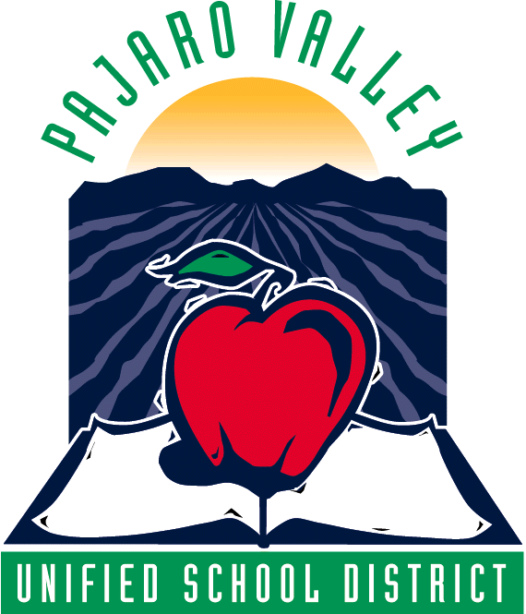

AGENDA

PVUSD Fiscal and Facilities Advisory Committee
August 15, 2011
3:30 – 5:00 p.m.
Adult Education Room 1

- Introductions

- Overview of work to date and issues for the near future

  - Implementation of AB 114 state budget language
  - Board initiated facility review and capital financing analysis

- Capital and program financing alternatives for PVUSD

Special Guest: Jared Boigon of TBWB – Jared has been retained by the district to assist in exploring possible bond and/or parcel tax financing for facility upgrades and alternative financing to protect key programs from state budget cuts

- Fiscal update – Implementation of State Budget Requirements

Next Meeting: September 19 at 3:30 p.m.

