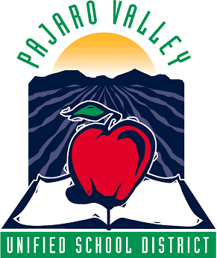
Pajaro Valley Unified School District

294 Green Valley Road Watsonville, California 95076
Phone (831) 786-2330 Fax (831) 728-6922

DATE: 03/01/2015
TO: All School Site Administrators
FROM: Colleen Bugayong, Accounting Supervisor
SUBJECT: Gift Card and Award Procedures REVISED

Please follow these procedures at your school site if you wish to partake in purchasing gifts or student rewards:

- Public (School/District) funds can be used to purchase gift cards and prizes as long as there is an audit trail showing the District is receiving a benefit and the rewards were for a public purpose. Funds used for a public purpose are not considered a “gift of public funds” within the meaning of legal opinions. And only the School Board can determine whether the expenditure serves a public purpose by adopting a Board Policy (BP).

- BP5126 states “….recognize students for unique or exemplary achievements in academic,
extracurricular or community service activities…… Student awards may include verbal recognition, a letter, a certificate, a Board resolution, public ceremony, trophy, gift, plaque or cash gift.”. Gift cards and Prizes can only be purchased for students in accordance with this policy. Gift cards can only be purchased for parents if it is written into a grant for direct student benefit. It is NOT permissible to purchase gift cards or prizes for community members or parents outside these parameters. Such a purchase constitutes a gift of public funds.

- District purchased gift cards and prizes can only be given to students or parents of the Pajaro Valley Unified School District.

- In addition to the Board Policy, the type of funding will also determine whether gift cards and prizes can be purchased. Generally, restricted programs do not allow such spending unless specified in the grant document. If there is any doubt please contact Fiscal Services or your Program coordinator before making the expenditure.

- In order to stay in line with the law and Board Policy, the gift cards and prizes must be pre-authorized and accounted for on the attached Acceptance form. Gift Cards cannot be purchased from an establishment that sells alcohol or tobacco in accordance with Ed Code.

- The Acceptance form must be accompanied by a description of the program and the rules for determining the person receiving the gift card or prize (i.e. the flyer) to demonstrate there is an allowable public purpose being served. Also, the person receiving the gift card or prize must certify (i.e. signature) they received it. Once all the gift cards or prizes have been distributed, this form and flyer must be attached to the gift card receipt and sent to Accounting Department.

- Under the laws of the IRS and Franchise Tax Board, if any recipient receives $600 or more in gift cards or prizes in a calendar year, the proper income tax reporting must be done on Form 1099 and required W9.
- PAJARO VALLEY UNIFIED SCHOOL DISTRICT

Gift Card/Prize Acceptance Form

_________________________________________________
School or Department

_________________________________________________
Activity/Function

_________________________________________________
Store(s)

By signing, I certify I have received a gift card or prize in the amount specified for my participation in the above activity during the date indicated.

NAME (Print and Sign) AMOUNT/ITEM DATE ACCEPTED

